Open Project in IntelliJ ------------------

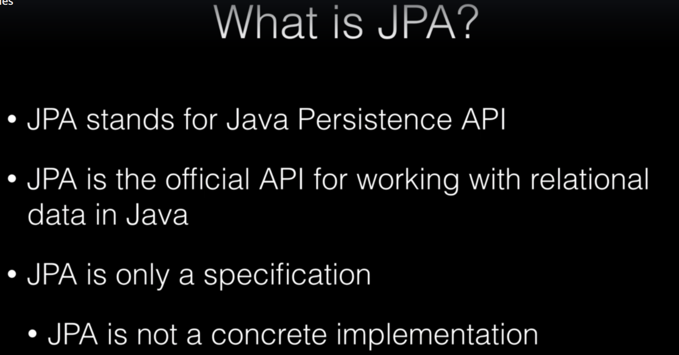

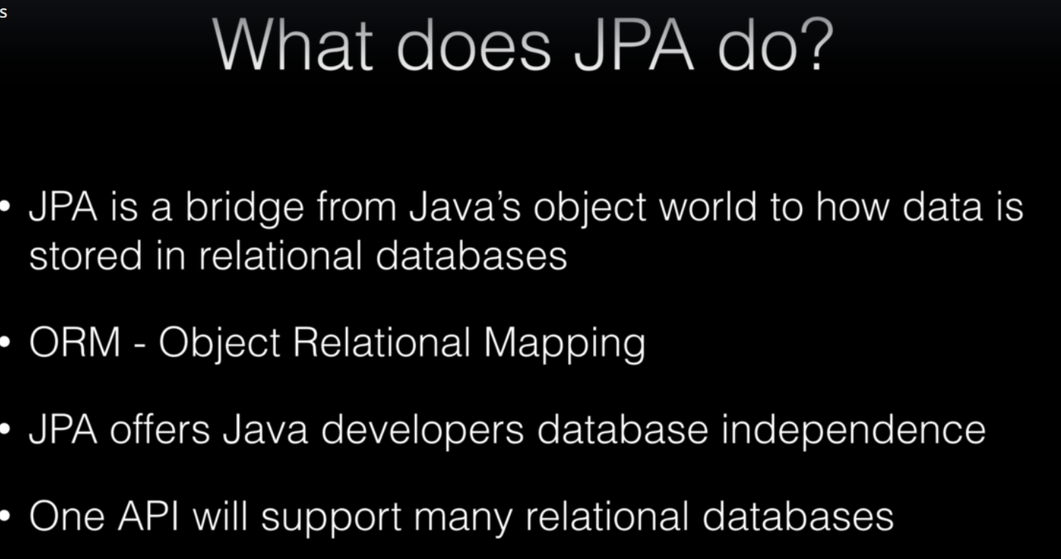

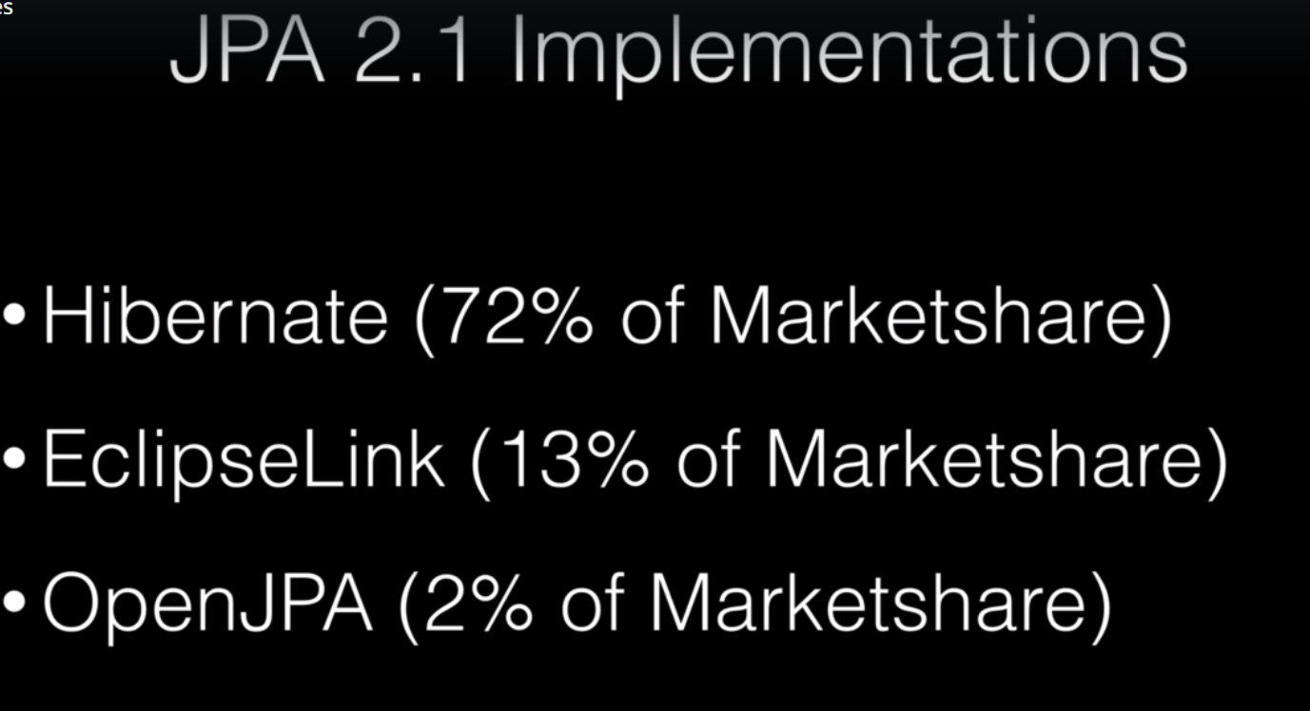

--------------- Spring Data JPA Repositories

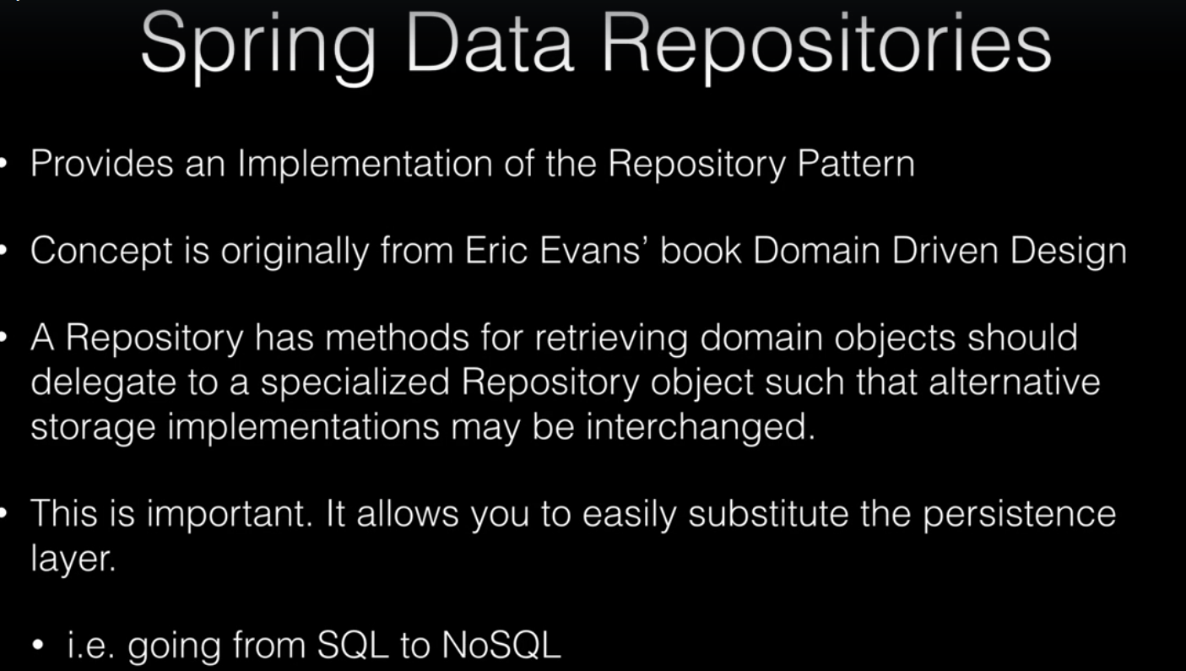

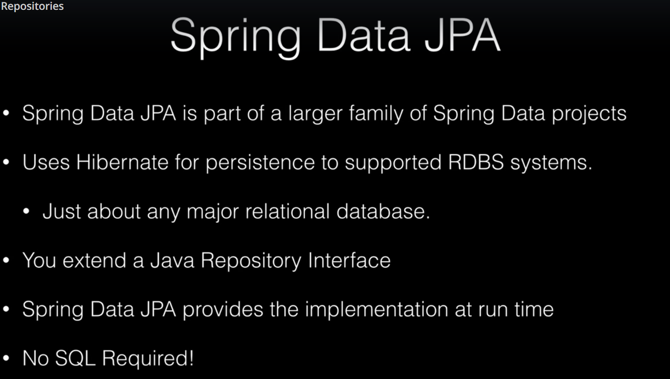

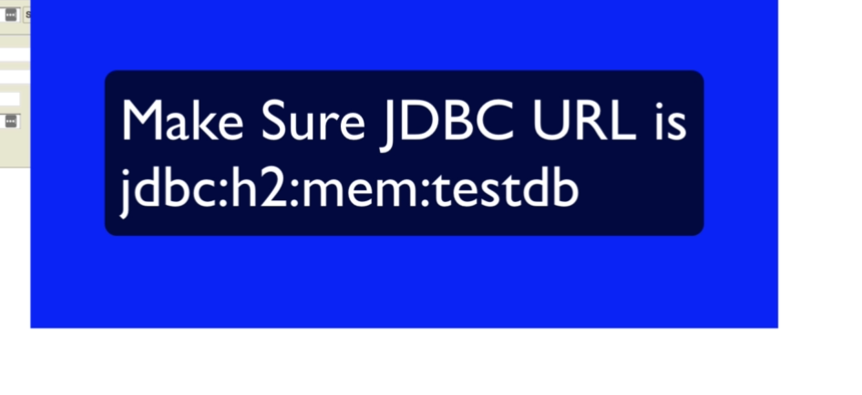

-------------- Introduction to Spring MVC



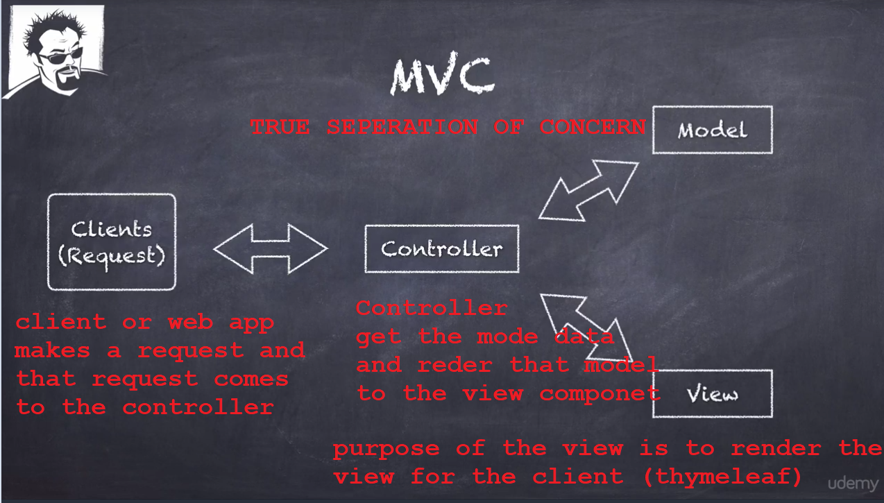

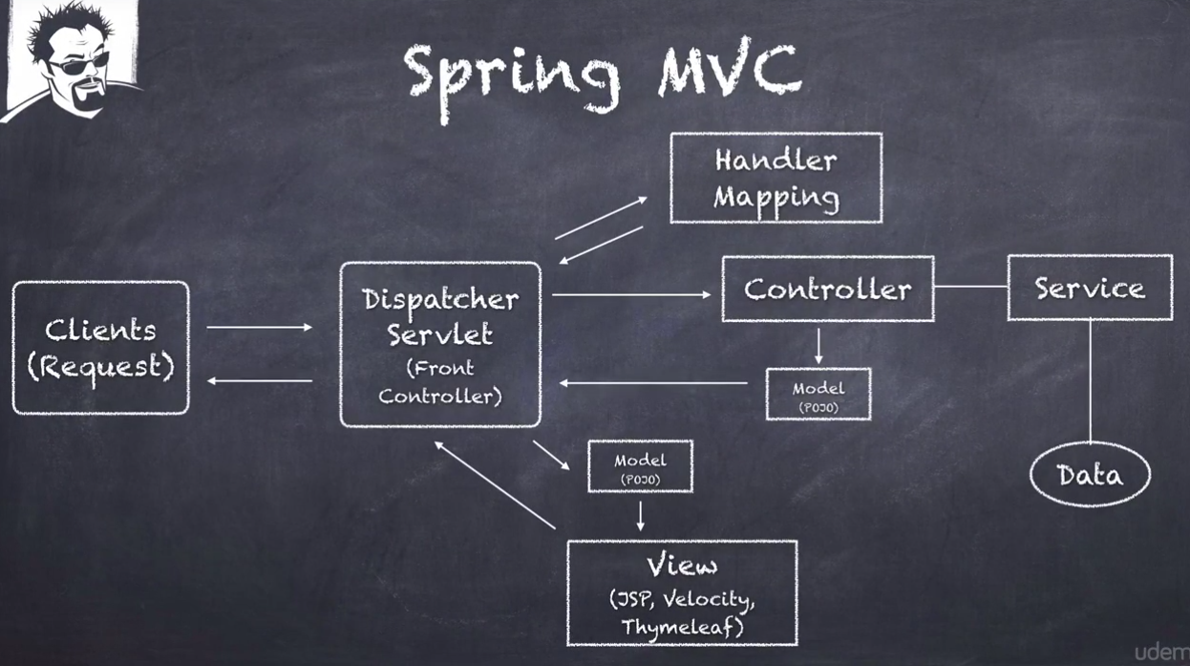

Configuring Spring MVC Controllers

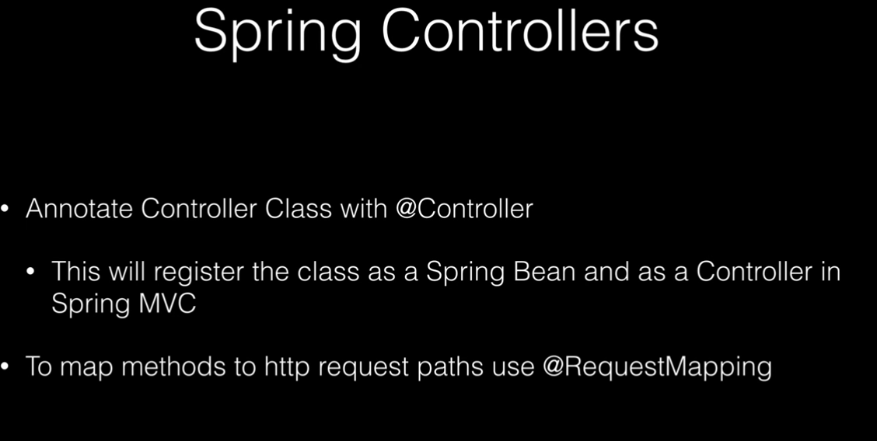

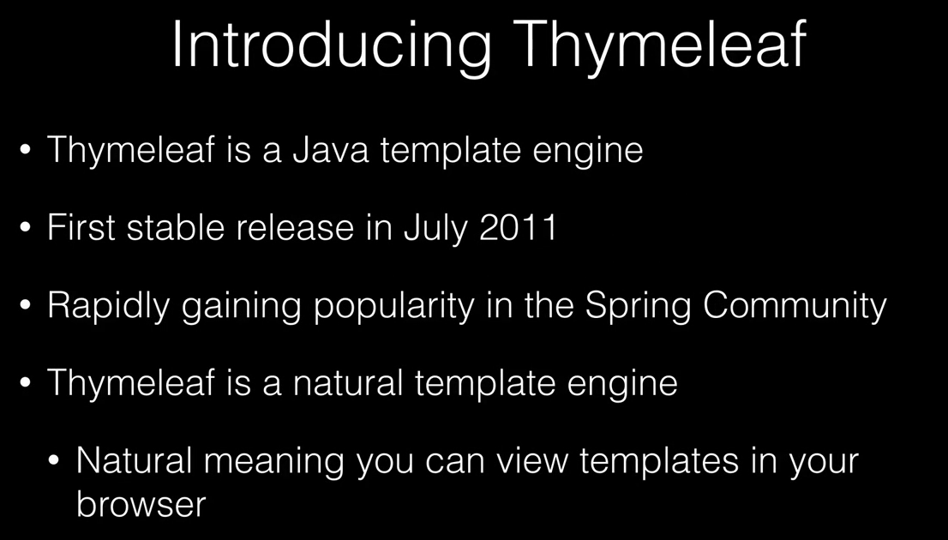

<!DOCTYPE html>  
<html lang="en" xmlns:th="http://www.thymeleaf.org">  
<head>  
 <meta charset="UTF-8"/>  
 <title>Spring Framework Guru</title>  
</head>  
<body>  
<h1>Book List</h1>  
  
<table>  
 <tr>  
 <th>ID</th>  
 <th>Title</th>  
 <th>Publisher</th>  
 </tr>  
 <tr th:each="book : ${books}">  
 <td th:text="${book.id}">123</td>  
 <td th:text="${book.title}">Spring in Action</td>  
 <td th:text="${book.publisher.name}">Wrox</td>  
 </tr>  
</table>  
  
</body>  
</html>

--------------------- Introduction to Spring Pet Clinic

